**Auto Insurance Claim Data Mart**

**Business Need:** Vice President of Auto Insurance Company wants to analyze the statistics of customers claims available from the insurance automation system. He would like an interactive analysis tool. Because Auto Insurance Automation System doesn’t have a Database, a data mart needs to be created.

|  |  |  |
| --- | --- | --- |
| **Measure** | **OLTP Fields** | **Data Type** |
| ClaimedAmount | Rejected flag | Money |
| PaidAmount | Rejected flag | Money |

Figure 1. Finalized measures for the Auto Insurance Claim Data Mart

|  |  |  |  |
| --- | --- | --- | --- |
| **Dimension** | **OLTP Fields** | **Data Type** | **Parent Dimension** |
| DimPolicy | DimPolicy | Int | DimPolicyType, DimCustomer |
| DimPolicyType | AccountingSystem.DimPolicyType | Int | None |
| DimCustomer | AccountingSystem.DimCustomer | Int | None |
| DimStatus | DimStatus | Int | None |
| DimProcessing | DimProcessing | Int | DimProcessingStage, DimDocument |
| DimProcessingStage | AccountingSystem.DimProcessingStage | Int | DimStaff |
| DimStaff | AccountingSystem.DimStaff | Int | DimStaffCategory |
| DimStaffCategory | AccountingSystem.DimStaffCategory | Int | None |
| DimDocument | AccountSystem.DimDocument | Int | DimDocumentType |
| DimDocumentType | AccountingSystem.DimDocumentType | Int | None |

Figure 2. Finalized dimensions and hierarchies for the Auto Insurance Claim Data Mart

|  |  |
| --- | --- |
| **AutoInsuranceClaimFact** | |
| **Field Name** | **Data Type** |
| ClaimedAmount | Money |
| PaidAmount | Money |

Figure 3. The Auto Insurance Claim Data Mart schema with measures in a fact table

|  |  |
| --- | --- |
| **AutoInsuranceClaimFact** | |
| **Field Name** | **Data Type** |
| ClaimedAmount | Money |
| ClaimDate | Datetime |
| PaidAmount | Money |
| SettlementDate | Datetime |

|  |  |
| --- | --- |
| **DimPolicy** | |
| **Field Name** | **Data Type** |
| PolicyID (PK) | Int |
| PolicyStartDate | Datetime |
| PolicyEndDate | Datetime |
| PolicyMonthlyRevenue | Money |

|  |  |
| --- | --- |
| **DimPolicyType** | |
| **Field Name** | **Data Type** |
| PolicyTypeCode (PK) | Int |
| PolicyTypeNames | Nvarchar(50) |
| PolicyTypeDescription | Nvarchar(50) |

|  |  |
| --- | --- |
| **DimCustomer** | |
| **Field Name** | **Data Type** |
| CustomerID (PK) | Int |
| CustomerName | Nvarchar(50) |
| CustomerAddress | Nvarchar(50) |
| CustomerGender | Nvarchar(50) |
| CustomerDateOfBirth | Datetime |

|  |  |
| --- | --- |
| **DimStatus** | |
| **Field Name** | **Data Type** |
| StatusCode (PK) | Int |
| StatusDescription | Nvarchar(50) |

|  |  |
| --- | --- |
| **DimProcessing** | |
| **Field Name** | **Data Type** |
| ProcessingID (PK) | Int |
| ProcessingDescription | Nvarchar(50) |
| ProcessingStartDate | Datetime |
| ProcessingEndDate | Datetime |

|  |  |
| --- | --- |
| **DimProcessingStage** | |
| **Field Name** | **Data Type** |
| ProcessingStageID (PK) | Int |
| StageStatusName | Nvarchar(50) |
| StageStatusDescription | Nvarchar(50) |

|  |  |
| --- | --- |
| **DimStaff** | |
| **Field Name** | **Data Type** |
| StaffID (PK) | Int |
| StaffName | Nvarchar(50) |
| StaffGender | Nvarchar(50) |
| StaffQualifications | Nvarchar(50) |

|  |  |
| --- | --- |
| **DimStaffCategory** | |
| **Field Name** | **Data Type** |
| StaffCategoryCode (PK) | Int |
| CategoryDescription | Nvarchar(50) |

|  |  |
| --- | --- |
| **DimDocument** | |
| **Field Name** | **Data Type** |
| DocumentID (PK) | Int |
| DocumentDescription | Nvarchar(50) |
| DateCreated | Datetime |

|  |  |
| --- | --- |
| **DimDocumentType** | |
| **Field Name** | **Data Type** |
| DocumentTypeCode (PK) | Int |
| DocumentTypeName | Nvarchar(50) |
| DocumentTypeDescription | Nvarchar(50) |

Figure 4. The Auto Insurance Data Mart schema with dimension tables added

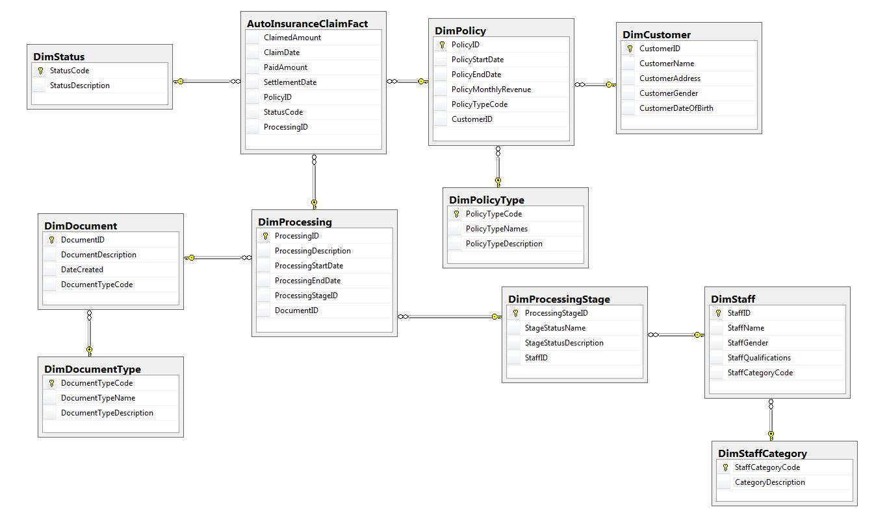

Figure 5. The Auto Insurance Data Mart Diagram

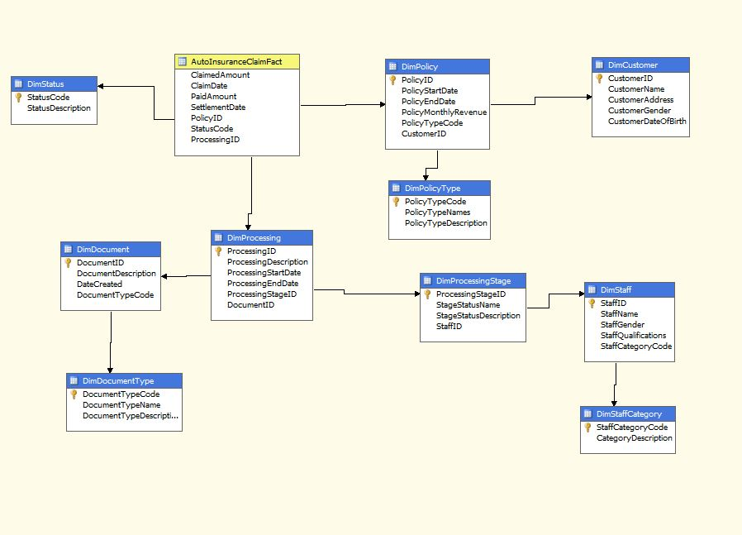

Figure 6. The Auto Insurance Data Mart Cube